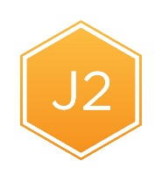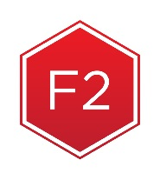

**Northern Arizona Healthcare**

**EntireCare Rehab & Sports Medicine**

**The Body-Swing Connection**

**For more information or RSVP, call Andrew Castelein, PT, AT/L, CSCS, at 928-773-2125 or email Andrew.Castelein@NAHealth.com.**

There isn’t one right way to swing a golf club, but there is a most efficient swing for each golfer that is based on their physical capabilities. Top amateurs and tour professionals have very good joint mobility, muscle flexibility, and strength which allows them to create efficient and powerful golf swings. Physical testing and 3D motion analysis are two of the best ways to determine what your physical capabilities are and how this impacts your golf swing.

At EntireCare, we use physical screening tests and 3D motion analysis through K-VEST to help identify any physical limitations that may be preventing you from producing an efficient and powerful golf swing. With this information, we help create a custom fitness program and work in conjunction with your golf teaching profession to help you eliminate your swing inefficiencies, recover from pain, and play better golf.

If you are interested in learning how your body can affect your golf swing come listen to Andrew Castelein, PT, AT/L, CSCS present on the concept of the body-swing connection at Flagstaff Medical Center in the McGee Auditorium on Tuesday October 25th at 5:00 p.m.

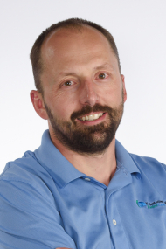

**About Andrew:**

Andrew is a physical therapist, athletic trainer, and strength and conditioning specialist with the EntireCare Rehab and Sports Medicine Experts department for Northern Arizona Healthcare. He works with clients at the Flagstaff Medical Center.

**Expertise and Special Interests:** Andrew has extensive experience in sports medicine and orthopedics. He treats a wide variety of orthopedic conditions including spine, shoulder, elbow, hip, knee, and foot/ankle injuries. Andrew also specializes in treating concussions and vestibular problems.

As an avid golf, Andrew also has a focus on helping golfers of all ages improve their flexibility and strength to optimize their golf swing. He holds Titleist Performance Institute certifications for medical professionals, fitness professionals, power training, and junior development. The Titleist Performance Institute is the world’s leading educational organization dedicated to the study of how the human body functions in relation to the golf swing.

**Education:** Andrew received his Bachelor of Science degree in Kinesiology from the University of Illinois. He earned a Master of Science degree in Exercise Science from the University of Oregon, and holds a clinical Doctorate in Physical Therapy from Northern Arizona University.

**Telehealth will be offering a seminar on community outreach February 16, 2018**