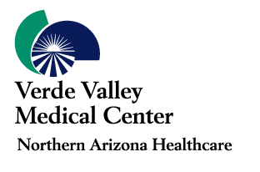
Medical Student Rotation Request Form

INSTRUCTIONS:
  - Complete this form and email your request to laurie.bueno@nahealth.com at least 3 months prior to the date of the requested rotation. Please indicate “MEDICAL STUDENT ROTATION REQUEST” in the subject line. Only email requests will be processed.
  - The following documents must be received by the GME office at least one month prior to the start of the rotation:
    - Letter of Good Standing
    - Proof of Insurance Coverage
    - Evidence of current immunizations (good through the entire time of the rotation)

Name: | First: |  |  | M.I.: | Last:
DOB: |  |  |  |  |  |  | Male | Female
Address: | Street: |  | City: |  |  |  | State: | Zip:
Phone: | Home: Preferred | Cell: Preferred |  |  |  | Other: Preferred
Email Address:

School Affiliation: |  |  | MS Year:
Specialty/  Elective: | First Choice: |  | Dates of Rotation: | From: | To:
Specialty/  Elective: | Second Choice: |  | Alternate  Dates: | From: | To:
Have you ever rotated here before?  Yes No |  | When? | With who?
*Please note that we do not provide housing. If housing is needed, student will need to make arrangements to procure.
Are you currently interested in our Internal Medicine Residency program?
Yes No
Are you willing to do night call one time per week in Internal Medicine?
Yes No
Why are you interested in rotating at VVMC?

Do you have any special needs/circumstances that will need to be addressed in order to rotate at VVMC?

School contact/coordinator information:

Note:
- If you currently attend a school that does not have an Affiliation Agreement with VVMC, this Agreement may take a few months to finalize. Rotations will not be confirmed without a fully executed Affiliation Agreement.
- Priority will be given to fourth year medical students and students interested in applying to our residency program.
- Prior to your rotation at VVMC, your school will need to provide your letter of good standing, proof of insurance and immunization records.

Thank you for your interest in Verde Valley Medical Center. We look forward to meeting you soon!
Verde Valley Medical Center Graduate Medical Education Program  269 South Candy Lane, Cottonwood, AZ 86326  (928) 639-6333

